**Exercise 1: Create a Simple View**

DROP TABLE IF EXISTS Employees;

DROP TABLE IF EXISTS Departments;

-- Step 2: Create Departments table

CREATE TABLE Departments (

DepartmentID INTEGER PRIMARY KEY,

DepartmentName TEXT

);

-- Step 3: Create Employees table

CREATE TABLE Employees (

EmployeeID INTEGER PRIMARY KEY,

FirstName TEXT,

LastName TEXT,

DepartmentID INTEGER,

FOREIGN KEY (DepartmentID) REFERENCES Departments(DepartmentID)

);

-- Step 4: Insert sample data into Departments

INSERT INTO Departments VALUES

(1, 'HR'),

(2, 'IT'),

(3, 'Finance');

-- Step 5: Insert sample data into Employees

INSERT INTO Employees VALUES

(101, 'Alice', 'Smith', 1),

(102, 'Bob', 'Johnson', 2),

(103, 'Charlie', 'Williams', 3);

-- Step 6: Create the view vw_EmployeeBasicInfo

CREATE VIEW vw_EmployeeBasicInfo AS

SELECT

e.EmployeeID,

e.FirstName,

e.LastName,

d.DepartmentName

FROM Employees e

JOIN Departments d ON e.DepartmentID = d.DepartmentID;

-- Step 7: Query the view

SELECT * FROM vw_EmployeeBasicInfo;

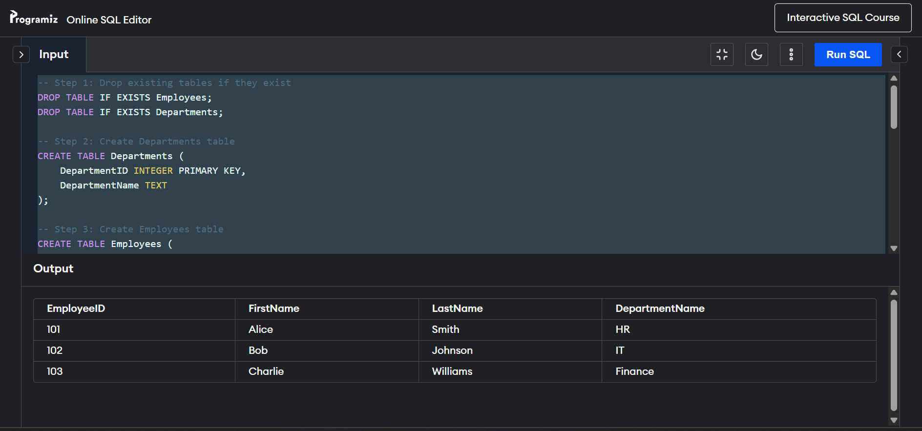

**Exercise 2: Add Computed Column - Full Name**

-- Step 1: Drop view if it already exists

DROP VIEW IF EXISTS vw_EmployeeFullName;

-- Step 2: Create the view with computed FullName column

CREATE VIEW vw_EmployeeFullName AS

SELECT

e.EmployeeID,

e.FirstName || ' ' || e.LastName AS FullName,

d.DepartmentName

FROM Employees e

JOIN Departments d ON e.DepartmentID = d.DepartmentID;

-- Step 3: Query the view

SELECT * FROM vw_EmployeeFullName;

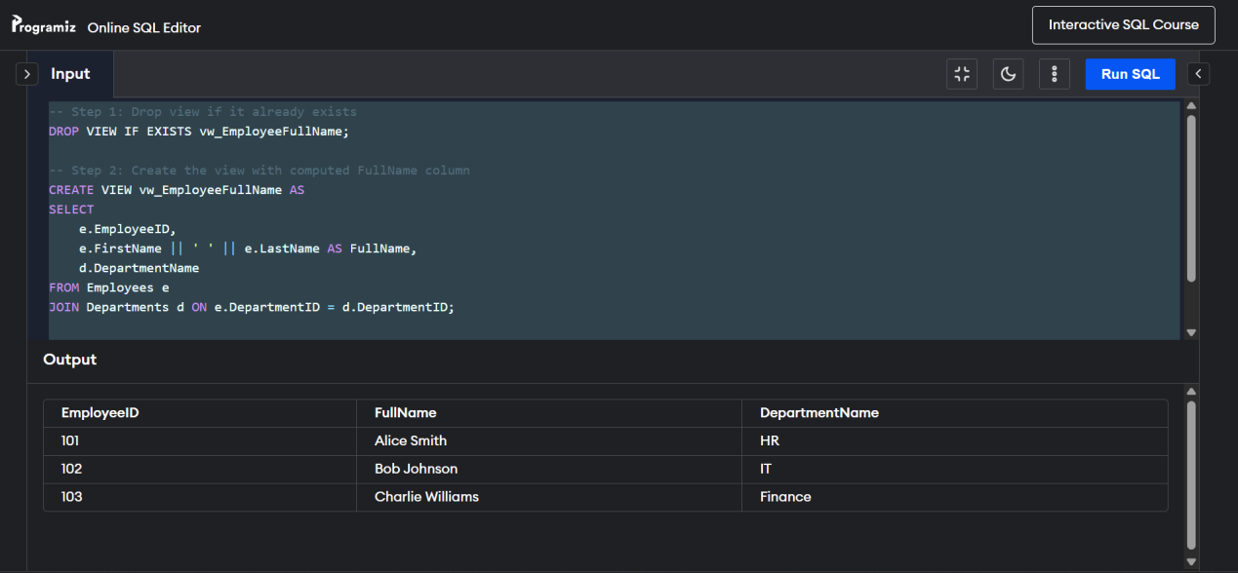

**Exercise 3: Add Computed Column - Annual Salary**

-- Step 1: Drop existing tables and views if they exist

DROP VIEW IF EXISTS vw_EmployeeAnnualSalary;

DROP TABLE IF EXISTS Employees;

-- Step 2: Recreate Employees table with Salary column

CREATE TABLE Employees (

EmployeeID INTEGER PRIMARY KEY,

FirstName TEXT,

LastName TEXT,

DepartmentID INTEGER,

Salary REAL

);

-- Step 3: Insert sample employee data

INSERT INTO Employees VALUES

(101, 'Alice', 'Smith', 1, 5000),

(102, 'Bob', 'Johnson', 2, 6000),

(103, 'Charlie', 'Williams', 3, 5500);

-- Step 4: Create the view with computed AnnualSalary

CREATE VIEW vw_EmployeeAnnualSalary AS

SELECT

EmployeeID,

FirstName,

LastName,

Salary,

Salary * 12 AS AnnualSalary

FROM Employees;

-- Step 5: Query the view

SELECT * FROM vw_EmployeeAnnualSalary;

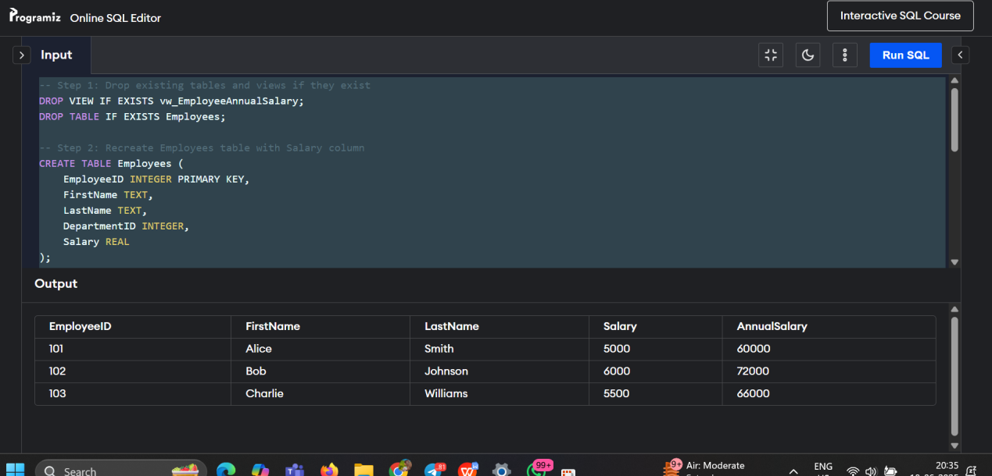

**Exercise 4: Add Multiple Computed Columns**

-- Step 1: Drop existing view and tables if needed

DROP VIEW IF EXISTS vw_EmployeeReport;

DROP TABLE IF EXISTS Employees;

DROP TABLE IF EXISTS Departments;

-- Step 2: Recreate Departments table

CREATE TABLE Departments (

DepartmentID INTEGER PRIMARY KEY,

DepartmentName TEXT

);

-- Step 3: Recreate Employees table with Salary and DepartmentID

CREATE TABLE Employees (

EmployeeID INTEGER PRIMARY KEY,

FirstName TEXT,

LastName TEXT,

DepartmentID INTEGER,

Salary REAL,

FOREIGN KEY (DepartmentID) REFERENCES Departments(DepartmentID)

);

-- Step 4: Insert sample Departments

INSERT INTO Departments VALUES

(1, 'HR'),

(2, 'IT'),

(3, 'Finance');

-- Step 5: Insert sample Employees

INSERT INTO Employees VALUES

(101, 'Alice', 'Smith', 1, 5000),

(102, 'Bob', 'Johnson', 2, 6000),

(103, 'Charlie', 'Williams', 3, 5500);

-- Step 6: Create view with multiple computed columns

CREATE VIEW vw_EmployeeReport AS

SELECT

e.EmployeeID,

e.FirstName || ' ' || e.LastName AS FullName,

d.DepartmentName,

e.Salary * 12 AS AnnualSalary,

(e.Salary * 12) * 0.10 AS Bonus

FROM Employees e

JOIN Departments d ON e.DepartmentID = d.DepartmentID;

-- Step 7: Query the view

SELECT * FROM vw_EmployeeReport;

